
Handwriting Progression at East Park Primary School

Foundation Stage
In FS1 we begin to look at forming letters. In phonics sessions, children are encouraged to 'high plank' for strengthening core muscles while they write. We use the RWI terminology such as 'perfect pencil grip,', as well as their letter rhymes. Alongside that, we do lots of gross motor and fine motor activities and general mark making in order to develop skills to prepare children for writing.
In FS2, we teach children to write letters as they learn to read them. This helps children make clear connections between the sounds they learn, the letters they read, and the shapes they form when writing. We use Read Write Inc. (RWI) rhymes to support correct letter formation and reinforce these links.
Handwriting sessions include Martin Harvey warm-up activities to develop the physical skills required for writing, alongside the ‘Write the Letter’ activity from the RWI Speed Sound lesson plans.

Autumn Term
During the Autumn term, the focus is on developing the physical foundations required for handwriting.
Children build both gross and fine motor skills, which are essential for writing. Activities are delivered through fine motor/handwriting ability groups to ensure appropriate support and challenge.
Key focuses include:
- Developing gross motor control through movement and physical activities
- Strengthening fine motor skills through mark-making and practical tasks
- Learning the positional language of writing (e.g., up, down, across, around)
- Using plain paper to develop confidence in mark-making and early letter shapes
- Completing Martin Harvey warm-up activities to strengthen hand muscles
- Developing correct pencil grip, using Pinchy Parrot to teach and reinforce a tripod grip

Spring Term
In the Spring term, children begin to apply their physical skills to more structured handwriting practice.
Key focuses include:
- Introducing lines for writing
- Beginning to form letters in handwriting books
- Continuing Martin Harvey warm-ups to strengthen writing muscles
- Following the RWI letter order as children learn new sounds
- Practising letters in RWI handwriting families to support consistent formation:
- Around letters
- Down letters
- Curly letters
- Zigzag letters

Summer Term
In the Summer term, the focus is on improving accuracy, consistency, and independence in handwriting.
Children continue to:
- Practise correct pencil grip
- Refine accurate letter formation
- Develop confidence and fluency when writing letters
- Apply handwriting skills within their independent writing across the curriculum
- Through this progression, children develop the physical control, confidence, and letter formation skills needed to become successful early writers.

In Year 1, children begin to watch the Ruth Miskin Letter Village Stage 2 videos in handwriting lessons to reinforce the formation of individual letters. Year 2 continue with this until letter formation is secure. In the Summer Term, once most children are secure in their letter formation, Year 2 will move on to the Stage 3 videos, learning to join letters. Any children who are not secure in individual letter formation at this point will continue with Stage 2.
By the end of KS1, we aim for most children to be starting to join. All children should be secure in the formation of each letter.
In Year 3, children watch the Stage 3 videos, focusing on learning to join two letters and writing words that use these joins.
In Year 4, handwriting is still taught but this is now modelled by the teacher, focusing on the different joins and using these sessions as an opportunity to practise spelling key vocabulary.
By the end of Year 4, we aim for all children to be secure in joining letters. If needed, children will receive intervention in Y5 and 6 to ensure they are making progress in this skill.

At East Park Primary School, children in Years 1-4 have handwriting lines in all of the subject books, ensuring they have practice throughout the day of handwriting and ensuring they take pride in their presentation.
In the Summer Term of Year 4, children will complete handwriting lessons in books with lined paper, to help with the transition into Year 5, where they move away from the handwriting guide lines.

Size of lines in books:
FS2 – EX01
Y1 – EX02, then EX03 when appropriate
Y2 -EX03
In Y3 and Y4, children have EX04 books
Year 5 and 6 write in books with lined paper, moving away from the handwriting guide lines.

KS1 (Ruth Miskin Letter Village - Stage 2)
Each lesson focuses on one letter. Letters are grouped in their families so that children are able to focus on the letters that are formed the same way in sucession.
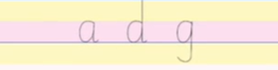
The children think of their lines as a sponge cake. The jam is in the middle and the two layers of sponge on the top and bottom. The three equal sections help the children know how long or tall to form the letters.
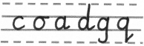
The coathanger family - a, d, g, o, c, q

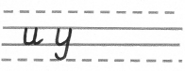
The smile family - u, y

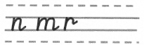
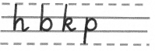
The bridge family - b. p, h, n, m, r

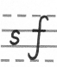
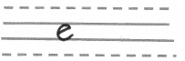
The misfits - e, s, f

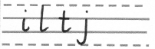
The straight line family - I, l, t, k, j

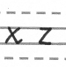
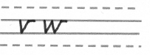
The zig zag family - v, w, x, z

Upper Case Letters
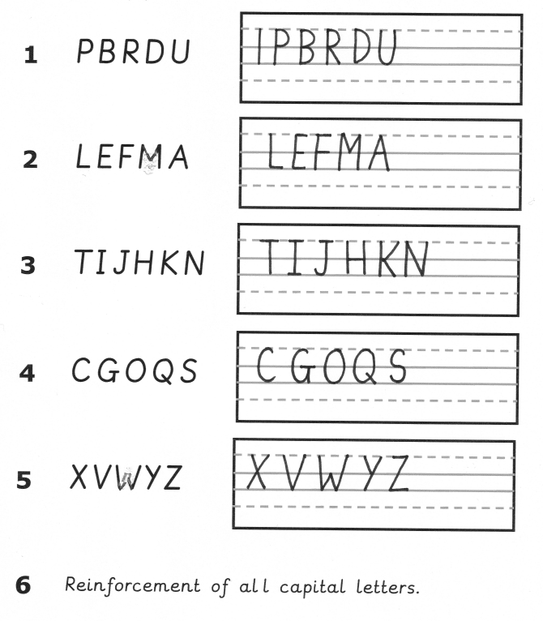

End of Y2 and Y3 (Ruth Miskin Letter Village Stage 3)
Hill to jam letters
Ai, du cr,
Mi, nu, hi,
By, pr, uv
Cup, tip, tum, lip, nip

Hill to top sponge letters
Ab, cl, ch
Mb, nk, th
Bl, ph, ib
Kit, bull, bulb, tilt, nutty

Hill to sister
Co, dg, da
Ma, no, nd
Ba, pa, ka
Dad, dig, add, can, back
Bridge to jam
Oi, or, ow
Wr, vu, fn
Ri, ry, rr
Fur, own, ring, warm, fruit

Bridge to top sponge
Ob, oh, ot
Wh, xt, wl
Rb, fl, rh
Owl, flap, off, whirl, vivid

Bridge to sister
Va, wa, wo
Fa, ro, ra
Oa, oo. Og
Frog, word, food, world, wrong

Hill to egg
He, ee, de

Bridge to egg
We, re, fe

Celebration day (egg)
Love, meet, cute, even, here

Joining to the snake
Hs, os, rs
Joining from the snake
Sw, so, se
Celebration day (snake)
Mess, most, easy, shop, does
Upper School (Y4, 5 and 6)
Step 1 – Individual Lower Case Letters
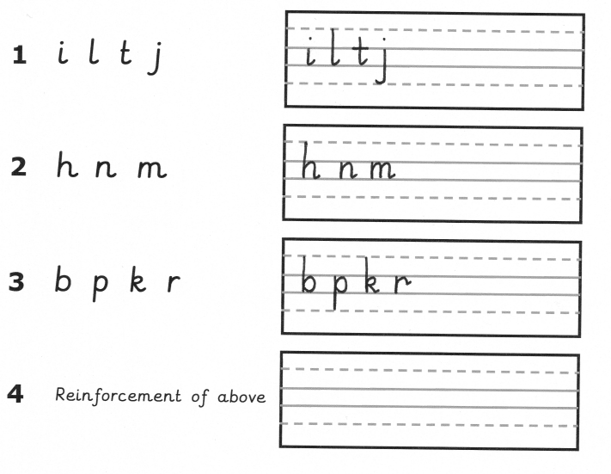

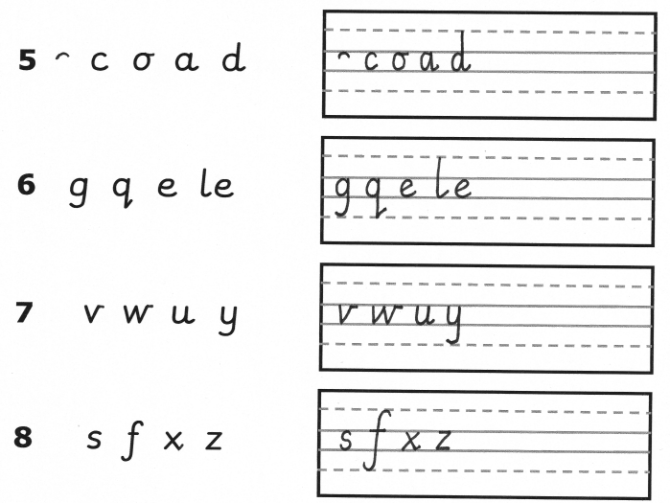

Step 2 – Upper Case Letters

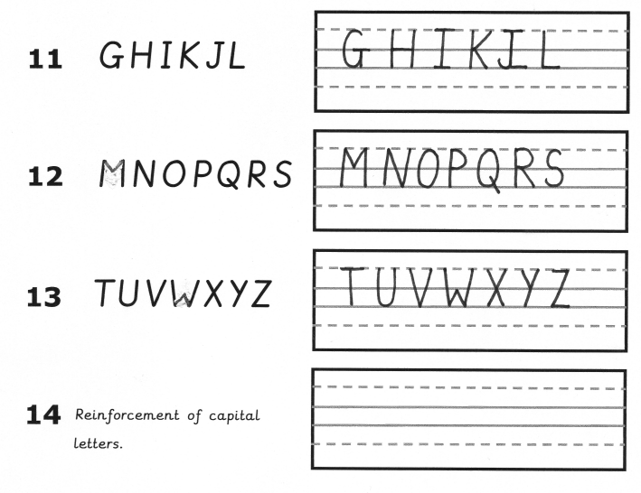
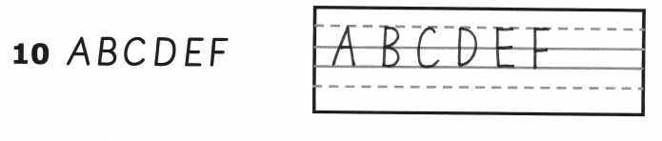

Step 3 – Suggested lessons on joining letters
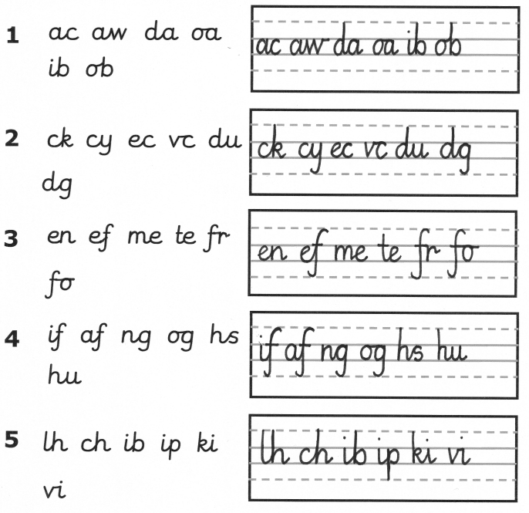

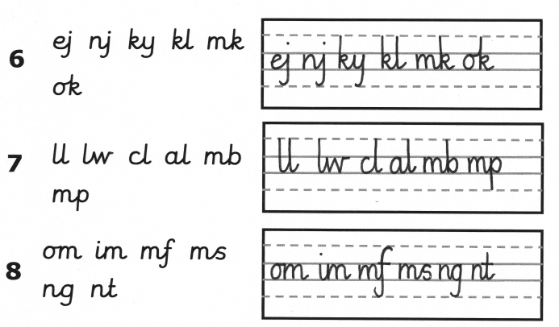

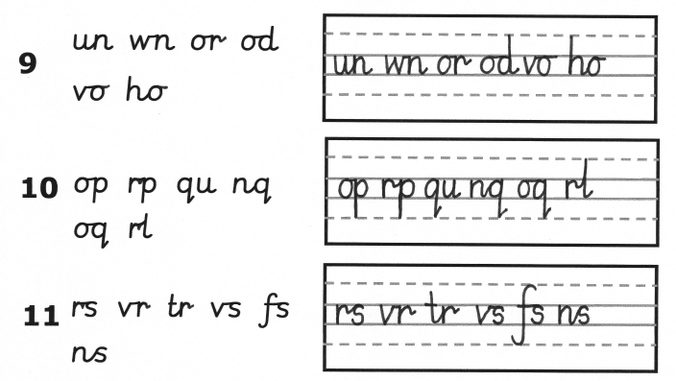

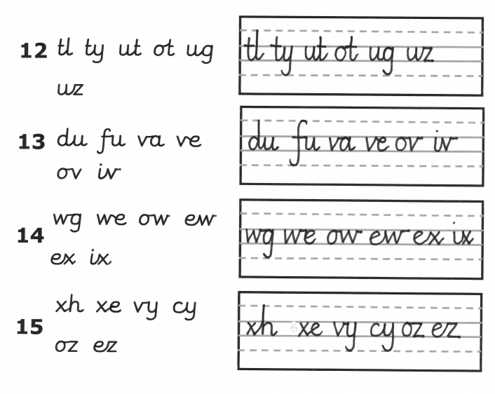

Terminology
Pencil grip
pinchy parrot, perfect pencil grip, imagine holding an apple, tomato, pea, put the pencil in the mouth with three fingers and flip the pencil into its bed

Posture
BBC – bottom in back of chair
TNT – tummy near table
2 hands – one holding the pencil and one resting on the table
6 feets on the floor – yours and the chair’s

Joins
Hill join – Handwriting hill joins letters from the bottom of the hill to the top of the jam, not too long, not too short, a gentle curve
Hill to jam (letters that join from the bottom, up to the top and a line straight down from there)
Hill to top sponge (letters that join from the bottom, up to the top solid line (a tall letter) and a line straight down from there)
Hill to sister (letters that join from the bottom, up the hill and over the sister’s head and back round – joining onto a coathanger letter)
Bridge join – the bendy bridge joins two letters at the top of the jam – not too droopy, not too tight
Bridge to jam (letters that join from the top of the jam and go across the bendy bridge and then a line striaght down from there)
Bridge to top sponge (letters that join from the top of the jam, go across the bendy bridge and then a straight line up to the top of the sponge and a line straight down from there)
Bridge to sister (letters that join from the top of the jam, go across the bendy bridge and then over the sister’s head and back round – joining onto a coathanger letter)
Hill/bridge to egg (joining to an ‘e’ from the bottom or top of the jam)
Hill/bridge to snake (joining to an ‘s’ from the bottom or top of the jam)

